

**SDMC Agenda**

**Wednesday, May 19, 2021**

**3:15 p.m. – MS TEAMS**

Welcome

Approve February 2021 Minutes

Update - SDMC Elections (Vote needed to move elections to next week)

Staffing Updates- 3rd Grade, Administrative Assistant/SIR

Approval of Professional Development Proposal 2021-2022 (Vote Needed)

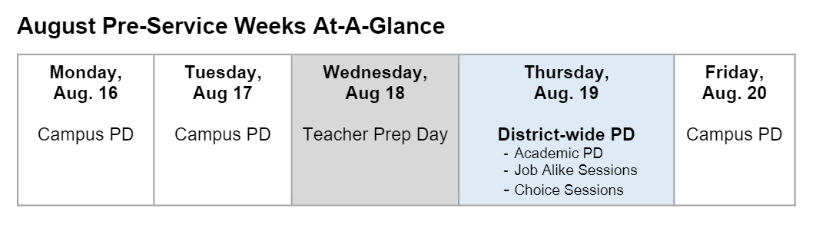

On Campus PD days, out topics would include: ReThink Ed Sessions (Socio-emotional Learning Curriculum – free online district resource for students); Café/Daily 5, Everyday Mathematics, IB, and GT 6 hr update. Compliances courses will be completed outside of the workday for Comp Time on October 4, 2021.

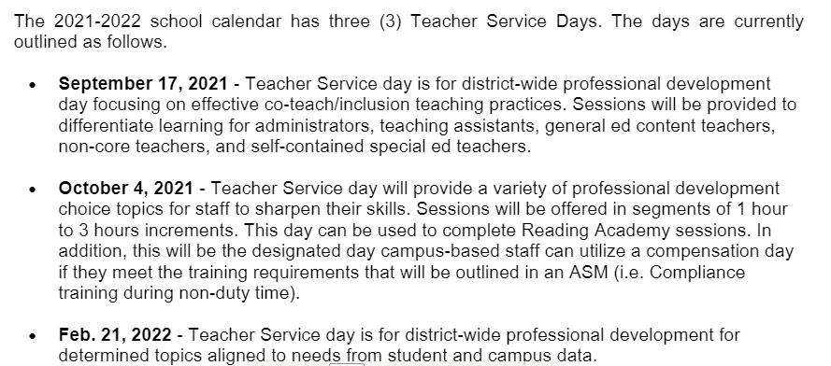

General SDMC/PTO Meeting – Vote Needed for April 13, 2022

ROE Budget Updates 2020-2022 School Year

Remaining Funds Per Category – as of 5/19/2021

|  |  |
| --- | --- |
| Name | Available |
| AFTER SCHOOL PROGRAM | 693.64 |
| PUA-BILINGUAL | 0 |
| CAMPUS CAPITAL | 592.72 |
| GIFTED&TALENTED | 2,223.64 |
| MAGNET PROGRAM | 1.35 |
| REGULAR PROGRAM | 544.18 |
| SPECIAL ED | -588 |
| VENDING MACHINE - Carries Over | 2,657.48 |

PTO Curriculum Proposal – Approved May 10, 2021 (Excerpt from proposal)

To continue to offer our students a differentiated, research based and relevant curriculum our students are accustomed to learning and our teachers are adept at providing, we are asking the PTO to allocate funding for additional curriculum resources for the 2021-2022 school year and beyond.

The faculty and staff at River Oaks Elementary understand the incredible gift the PTO is to the school and acknowledges that without them, we would not have access to the many resources and opportunities that you provide above and beyond the state’s curriculum. Specifically, the PTO has historically supported line items such as Technology ($20,000), Field Trips ($16,250), Staff Training ($20,000), IB Fees ($9,000), and Everyday Mathematics curriculum ($32,000), and these line items will remain. The Everyday Math budgetary items fluctuate depending on new adoption years, and online versus paper copies of items. We did not purchase the Skills Links books last year, and the students had a hard time looking at the book on screen and trying to work the problems. The grade levels unanimously feel the consumable books are necessary to support the students.

|  |  |  |  |
| --- | --- | --- | --- |
| VENDOR | ITEM | Budget | PRICE |
| HMHCO | Spelling Connections Curriculum 1st-5th (550 units) | PTO | $11,693.50 |
| HMHCO | Grammar 1st-5th Grammar (550 units) | PTO | $9,925.25 |
| School Specialty | Wordly Wise - Vocabulary Curriculum 2nd-5th (440 units) | PTO | $4,706.24 |
| Capstone | Pebble GO K, 1, 2 (Online Subscription) | PTO | $1,290.00 |
| Mentoring Minds | Math Think Up Print 3rd, 4th (220 units); ELAR Think Up Print 3rd-4th (220 units) | PTO | $7,835.00 |
| HMHCO | 5th Science Think Up Print (110) | PTO | $2,700.00 |
| Generation Genius | 5th Generation Genius Science (Online Subscription) | PTO | $400 |
| HMHCO | Everyday Math Skills Link Books (Consumables) | PTO | $8000 |
|  |  | TOTAL | $46,549.99 |

HISD Budget Resources/Recapture/Future Impacts <https://www.houstonisd.org/Page/173564>.

COVID Updates – Mask Mandate

Q & A